**CREATING A SOCIAL MEDIA AD CAMPAIGN IN FACEBOOK**

**META BUSINESS SUITE:**

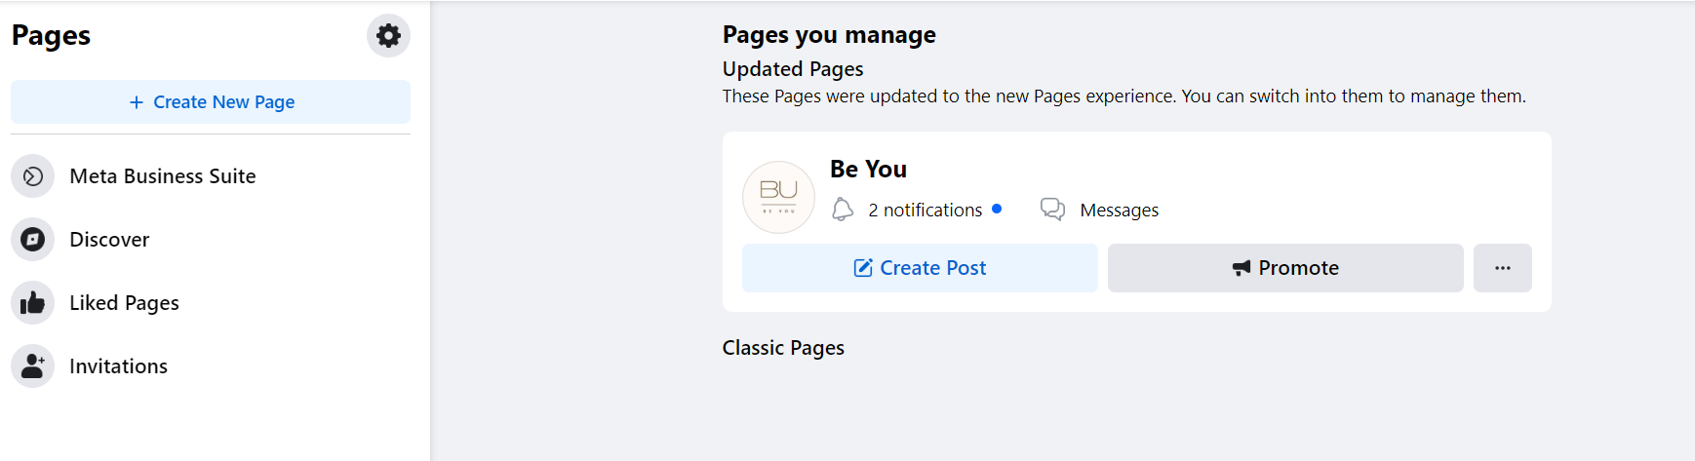

**ADS:**

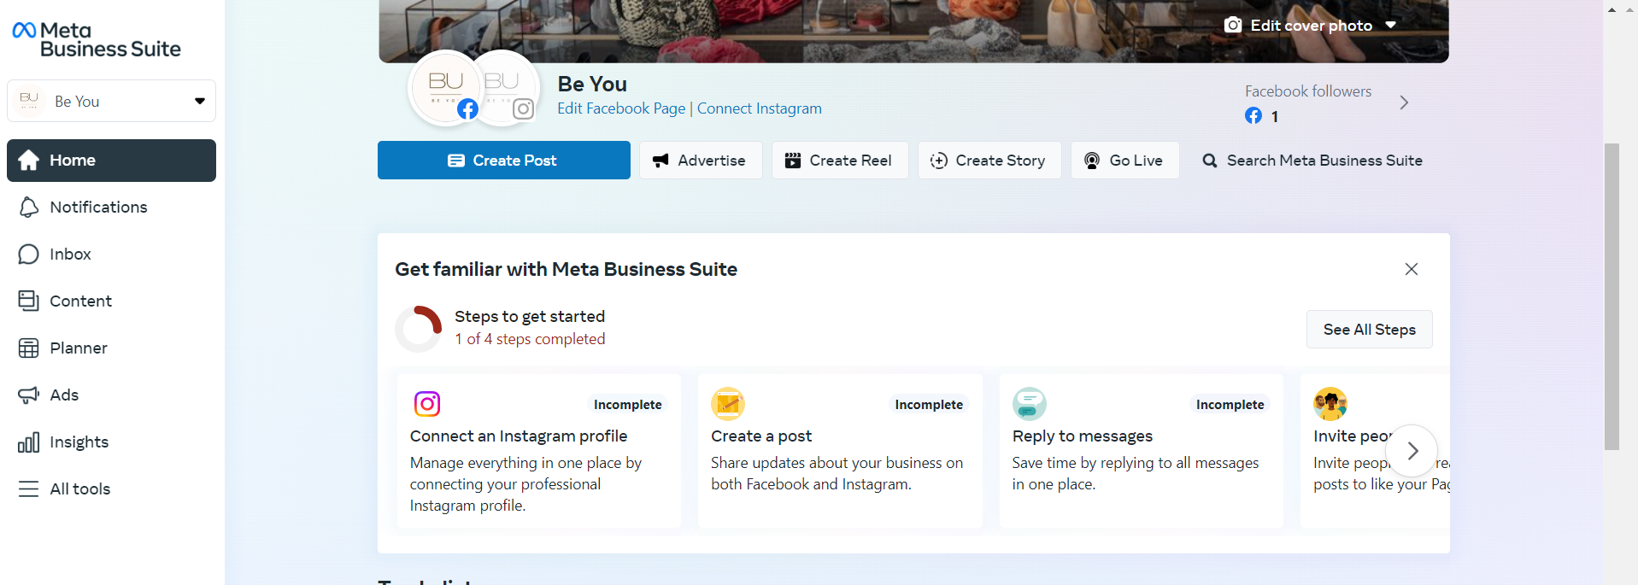

**CREATE NEW AD:**

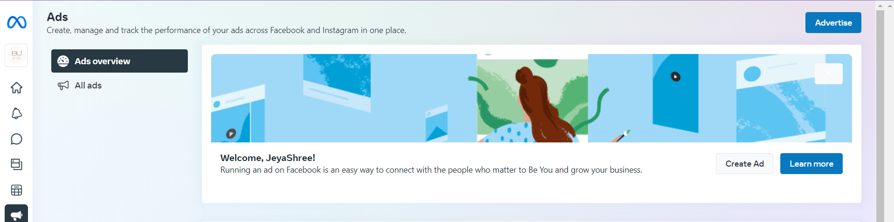

**CHOOSE MORE GOALS AND LEEDS:**

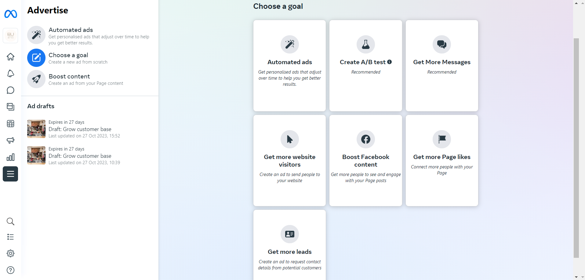

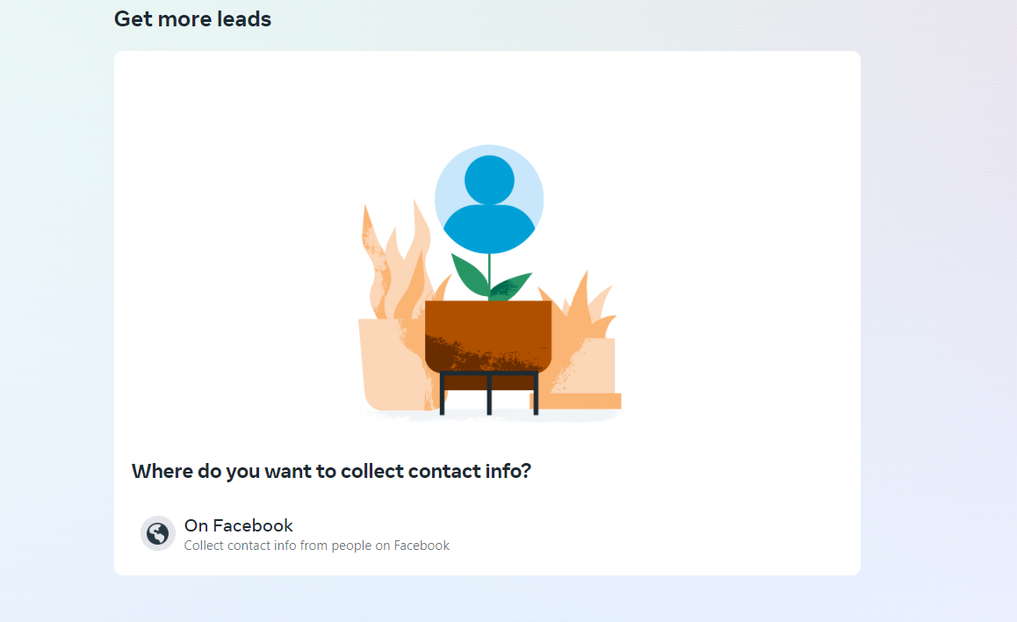

**CREATE NEW FORM:**

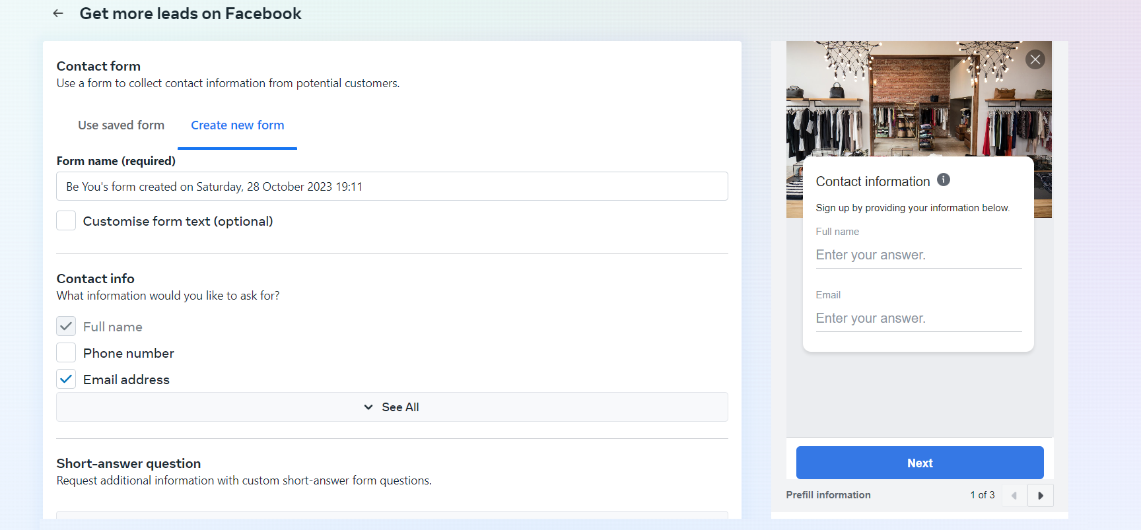

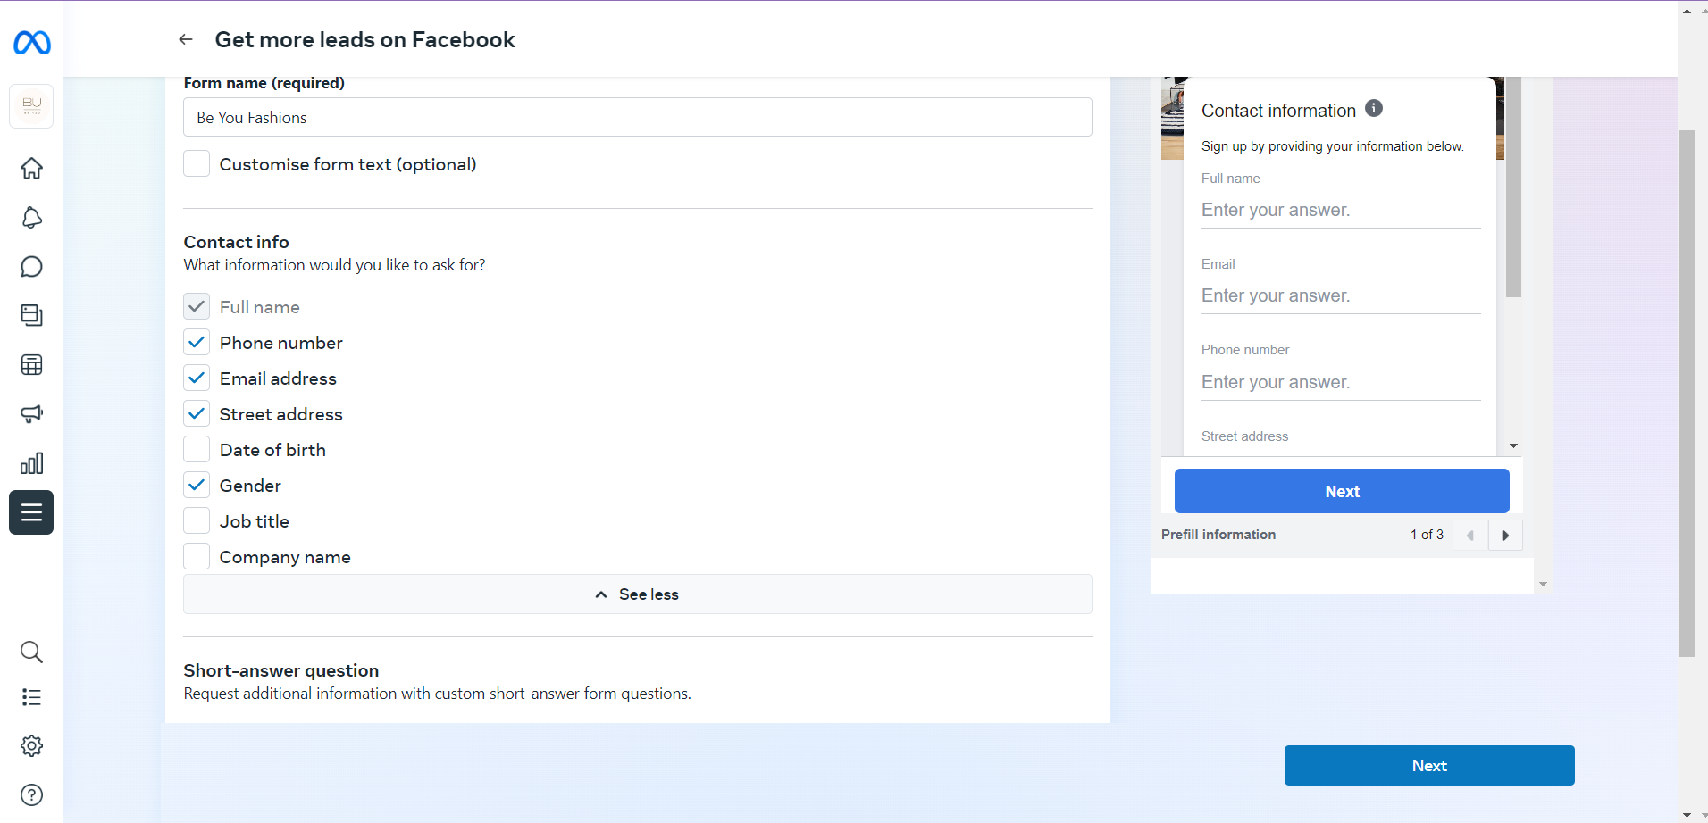

**DESCRIPTION AND HEADLINE:**

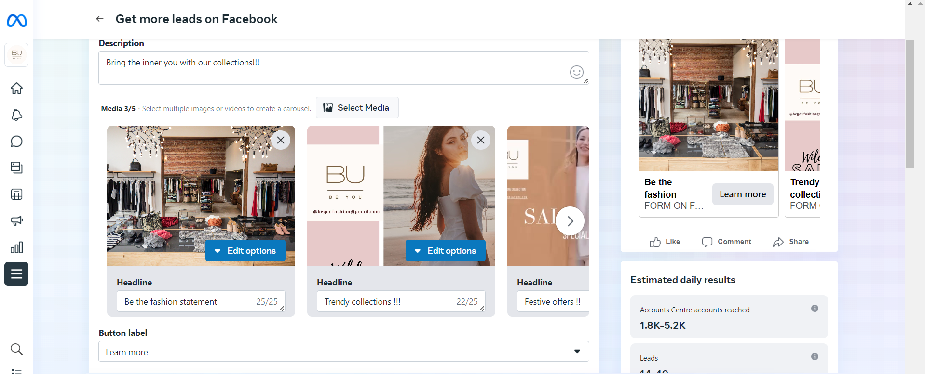

**ESTIMATED RESULTS:**

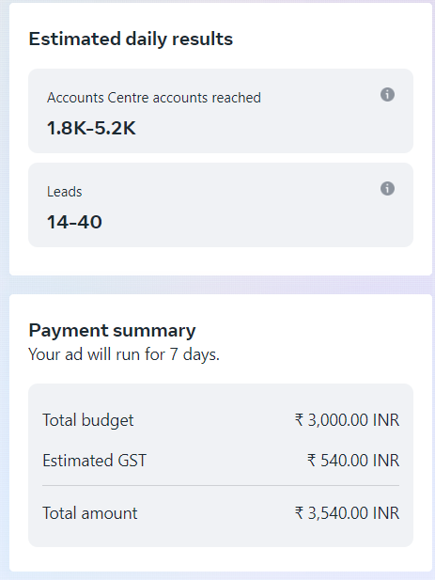

**CHOOSE YOUR AUDIENCE:**

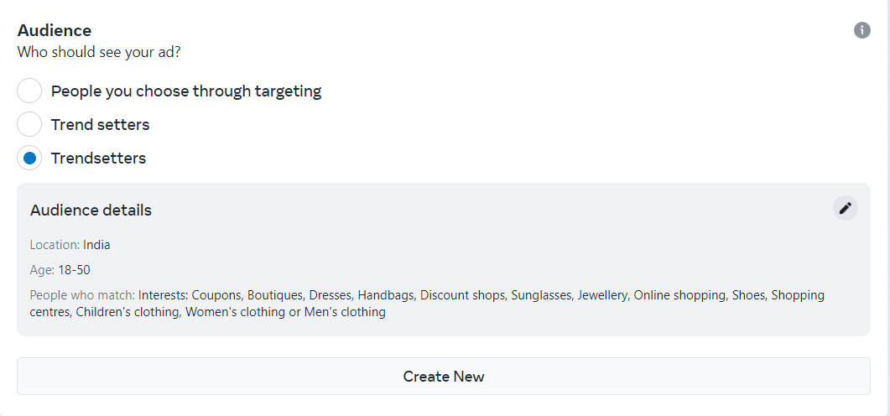

**SCHEDULE TIME AND BUDGET:**

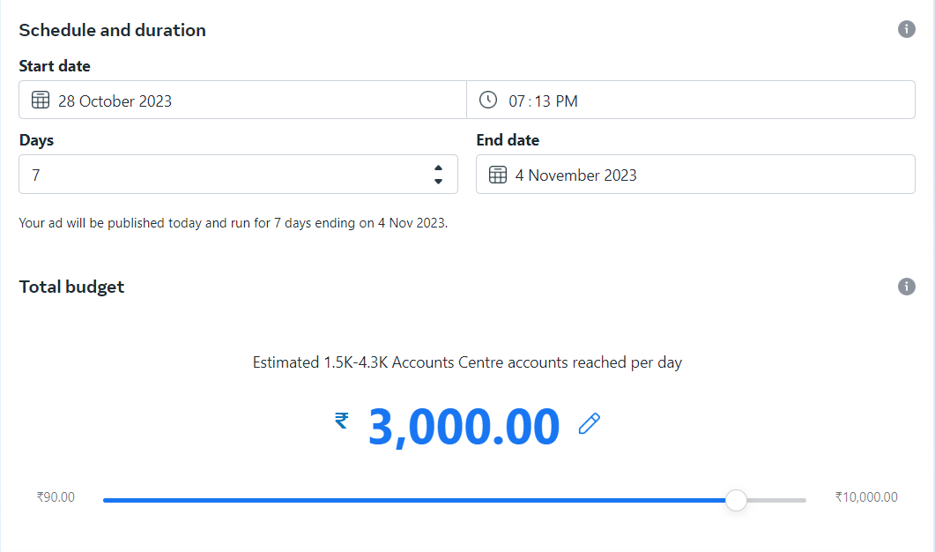

**PLACEMENTS:**

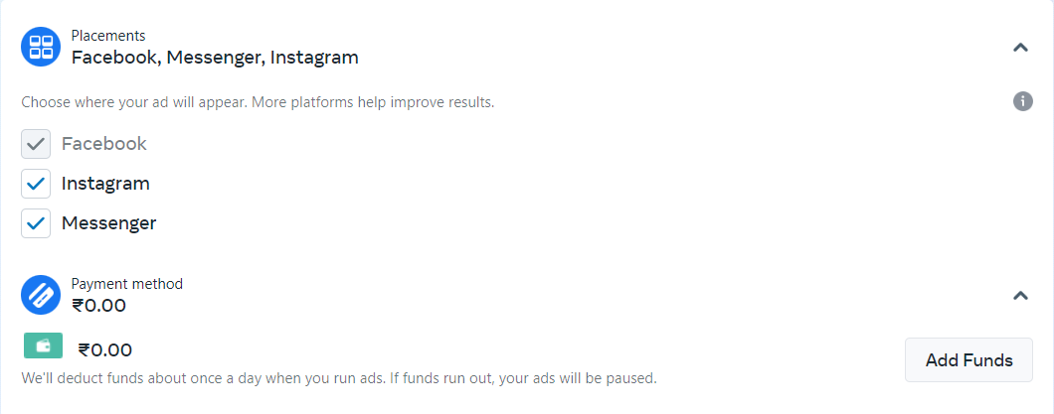

**PREVIEW:**

